# Environment

OS: Windows 7 Ultimate x64

Compiler: Visual Studio 2010

Boost: 1.57.0 (installation path is “D:\libs\boost”)

CMake: 3.2.1

Python3: 3.3.5

NumPy: 1.9.1

SciPy: 0.14.0

PyQt4: 4.10.3

Pyparsing: 2.0.1

python-dateutil: 2.2

six: 1.5.2

Git: 1.9.5

# Downloading

Boost: <http://sourceforge.net/projects/boost/files/boost/1.57.0/>

CMake: <http://www.cmake.org/files/v3.1/cmake-3.1.3-win32-x86.exe>

Python3: <http://www.python.org/ftp/python/3.3.5/python-3.3.5.msi>

NumPy: <http://sourceforge.net/projects/numpy/files/NumPy/1.9.1/numpy-1.9.1-win32-superpack-python3.3.exe/download>

SciPy: <http://sourceforge.net/projects/scipy/files/scipy/0.14.0/scipy-0.14.0-win32-superpack-python3.3.exe/download>

PyQt4: <http://sourceforge.net/projects/pyqt/files/PyQt4/PyQt-4.10.3/PyQt4-4.10.3-gpl-Py3.3-Qt4.8.5-x32.exe/download>

Pyparsing: <http://sourceforge.net/projects/pyparsing/files/pyparsing/pyparsing-2.0.1/pyparsing-2.0.1.win32-py3.3.exe/download>

setuptools: <https://pypi.python.org/pypi/setuptools#downloads>

python-dateutil: <https://pypi.python.org/pypi/python-dateutil/2.2>

six: <https://pypi.python.org/pypi/six/1.5.2>

Matplotlib: <http://sourceforge.net/projects/matplotlib/files/matplotlib/matplotlib-1.3.1/matplotlib-1.3.1.win32-py3.3.exe/download>

Git: <https://github.com/msysgit/msysgit/releases/download/Git-1.9.5-preview20141217/Git-1.9.5-preview20141217.exe>

# Compiling Boost

* Installing Python 3, and make sure its path is included in the PATH environment variable:

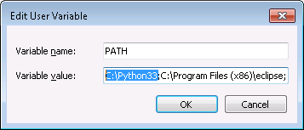

* Extracting source code files of Boost:

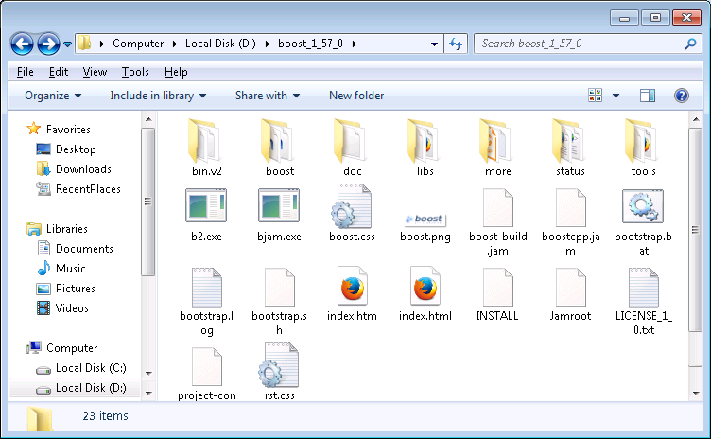

* Start the x86 command prompt of Visual Studio 2010:

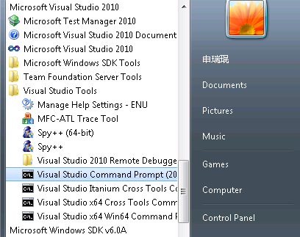

* Compiling Boost (both static and shared link):

d:

cd D:\boost_1_57_0

bootstrap.bat

b2 --prefix=D:\libs\boost install

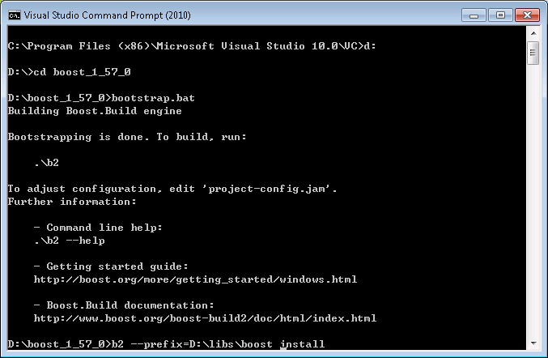

b2 --prefix=D:\libs\boost link=shared install

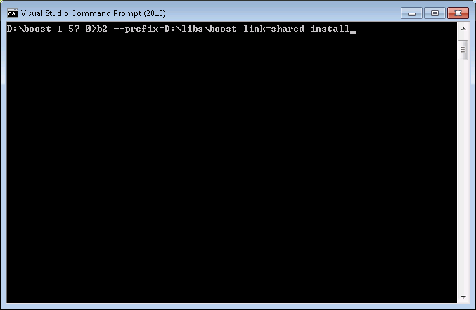

* Adding the installation path of Boost “D:\libs\boost” into both the PATH and BOOST_ROOT environment variables:

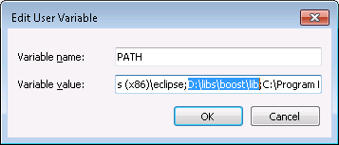

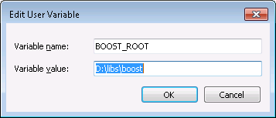

* Open the property manager of Visual Studio 2010, and adding the library path of Boost “D:\libs\boost\lib” into library directories:

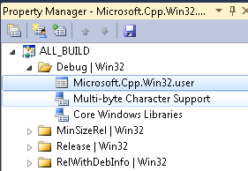

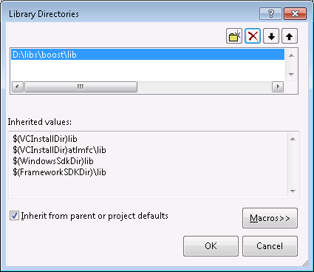

# Configuring OTL

* Clone the repository:

Clone URL: <https://github.com/O-T-L/OTL.git>

Destination: D:\git\OTL

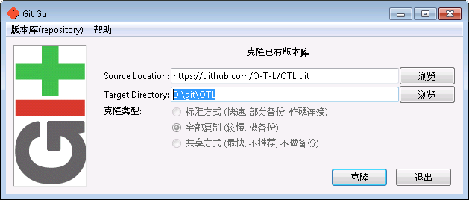

* Generating project files of Visual Studio 2010

Source code directory: D:\git\OTL\OptimizationTemplateLibrary

Binary directory: D:\VS2010\OptimizationTemplateLibrary

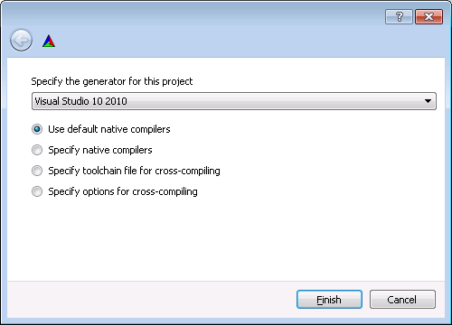

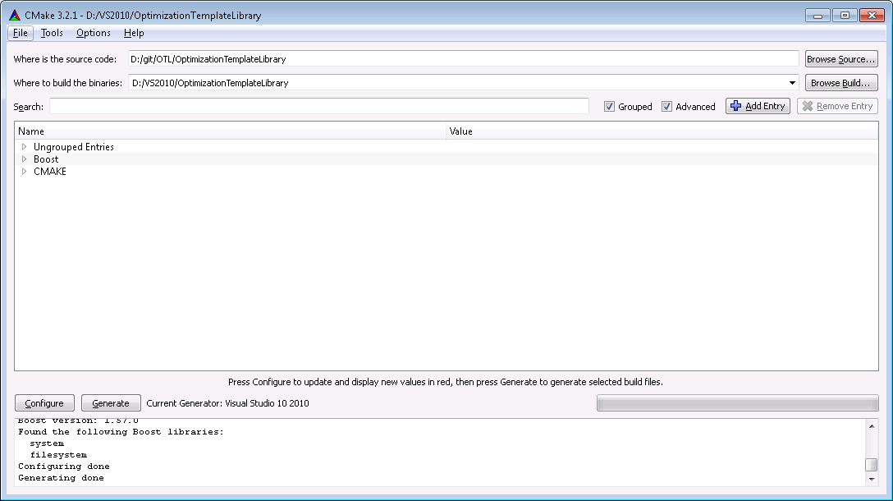

* Building the OTL project:

Choosing the “Release” building type will be better.

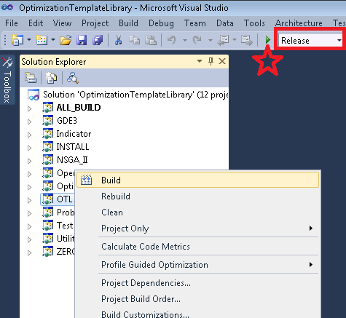

* Adding the binary directory of OTL “D:\VS2010\OptimizationTemplateLibrary” into the OTL_BINARY_DIR environment variable (optional):

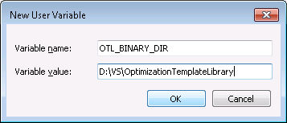

# Configuring PyOTL

* Clone the repository:

Clone URL: <https://github.com/O-T-L/PyOTL.git>

Destination: D:\git\PyOTL

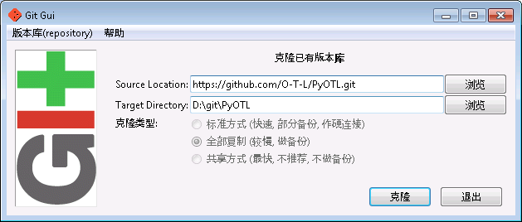

* Generating project files of Visual Studio 2010

Source code directory: D:\git\PyOTL\PyOTL

Binary directory: D:\VS2010\PyOTL

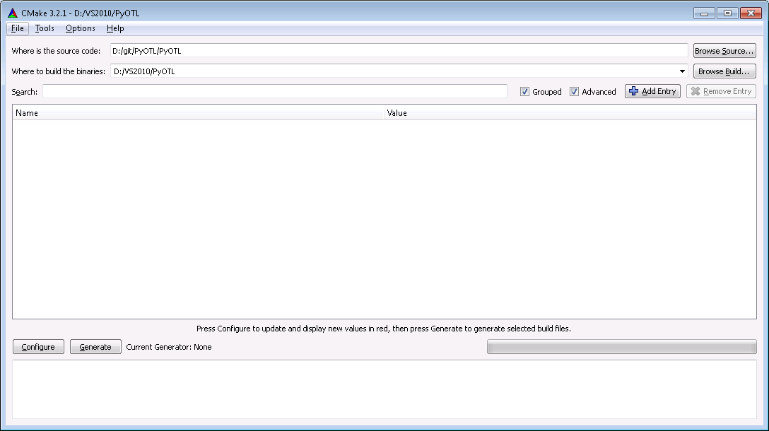

* If the OTL_BINARY_DIR environment variable is not set, then set the OTL_BINARY_DIR CMake variable into “D:\VS2010\OptimizationTemplateLibrary”:

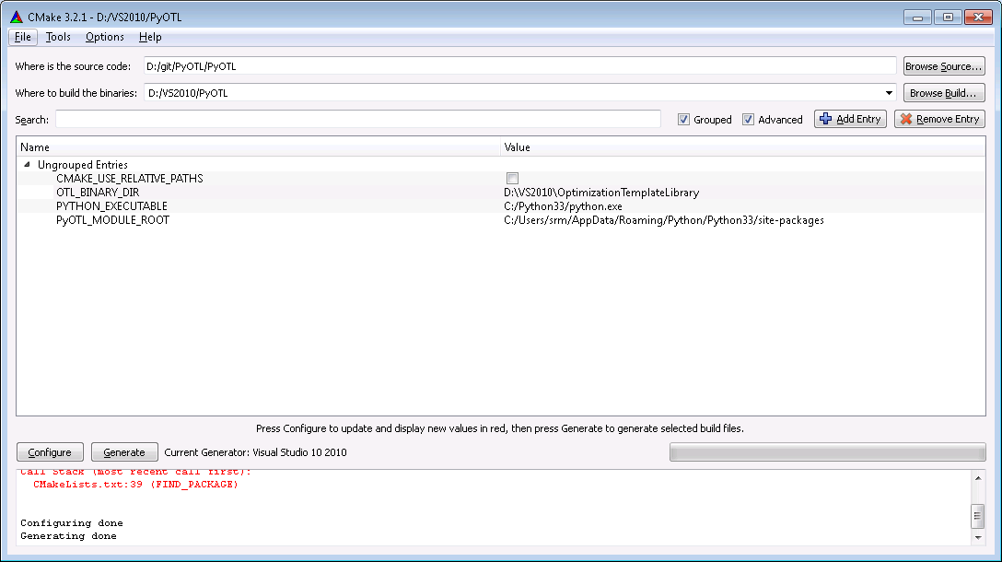

* Compiling all projects of PyOTL:

Choosing the “Release” building type will be better.

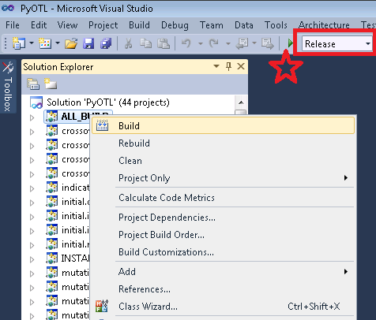

* If your memory is not enough, you can disable some optimization algorithms in “D:\git\PyOTL\PyOTL\Include\pyotl\optimizer\Switch.h”:

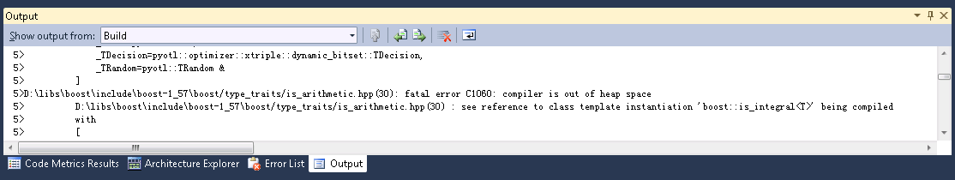

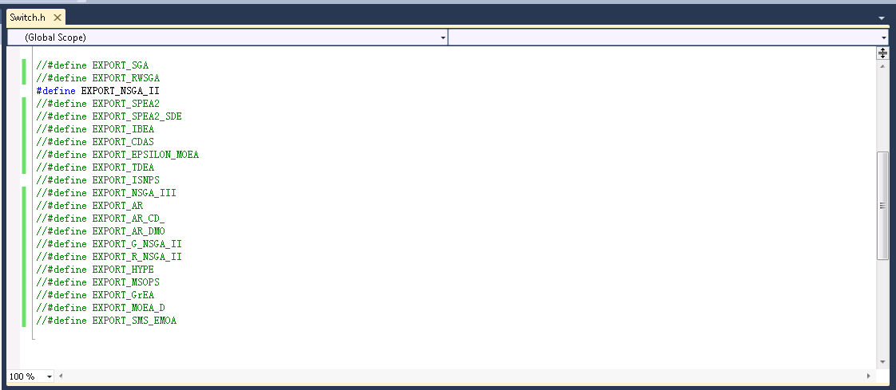

# Configuring PyOptimization

* Clone the repository:

Clone URL: <https://github.com/O-T-L/PyOptimization.git>

Destination: D:\git\PyOptimization

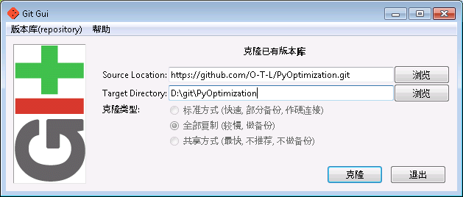

* Installing the Python libraries depended by PyOptimization:

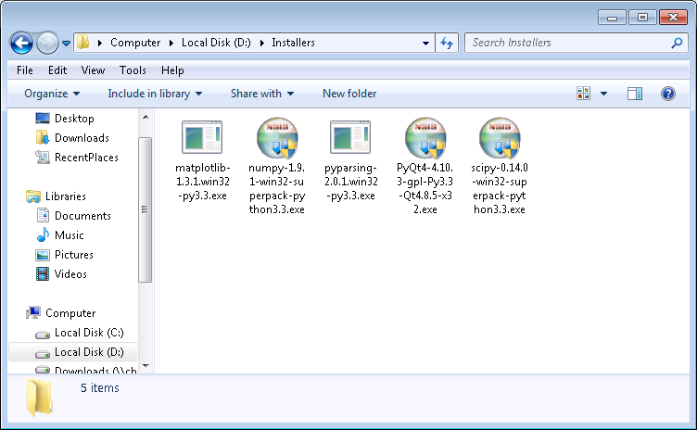

* Manually compiling the Python libraries depended by PyOptimization:

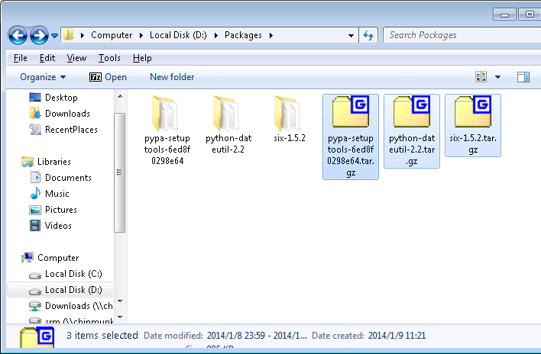

* Compiling setuptools:

python setup.py config

python setup.py build

python setup.py bdist_wininst

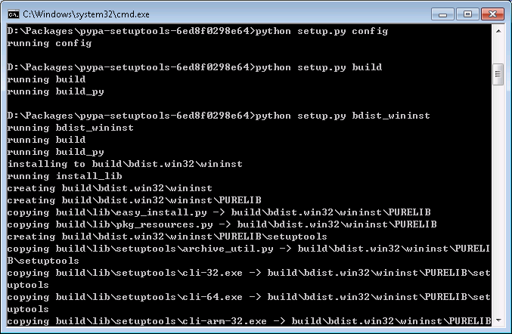

Run the installer as administrator.

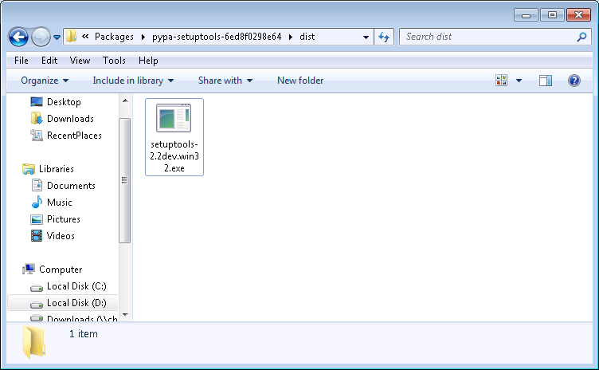

* Use the same way to compile python-dateutil and six:

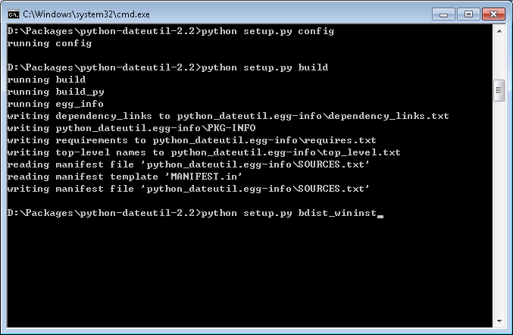

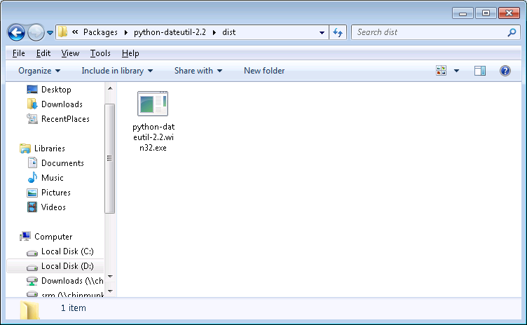

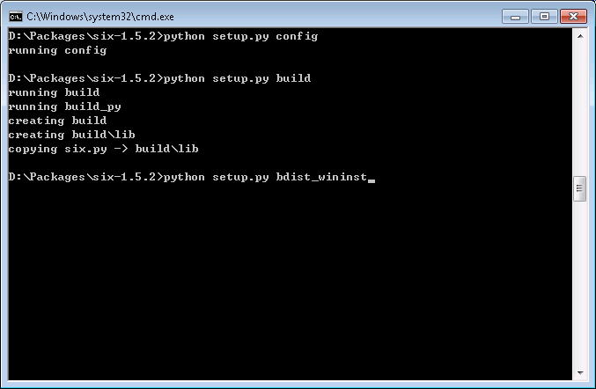

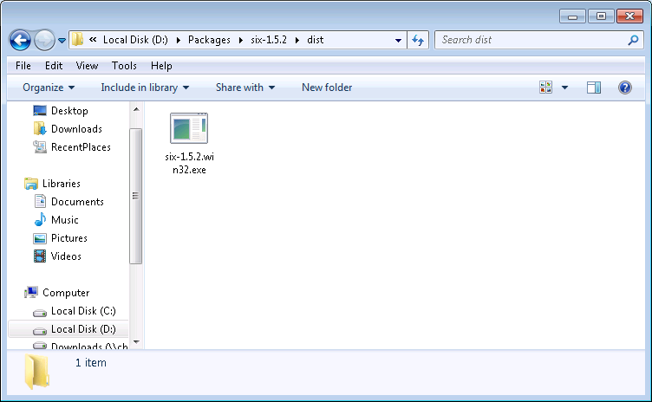

# Using PyOptimization

* Creating an empty database:

d:

cd D:\git\PyOptimization\PyOptimization

python reset.py

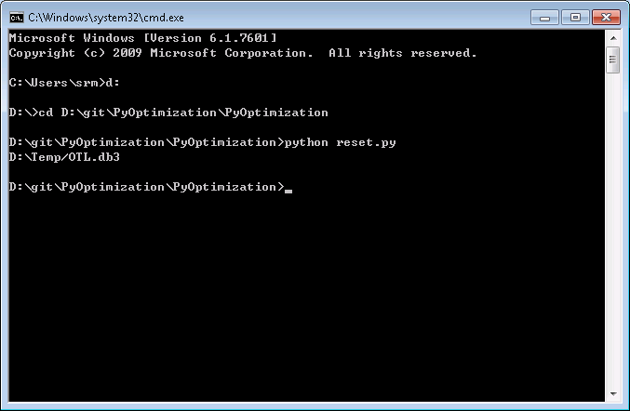

* Running optimization algorithms:

python optimization.py

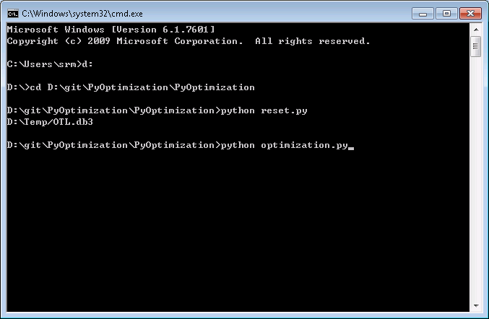

* Visualizing the results:

python visualize.py

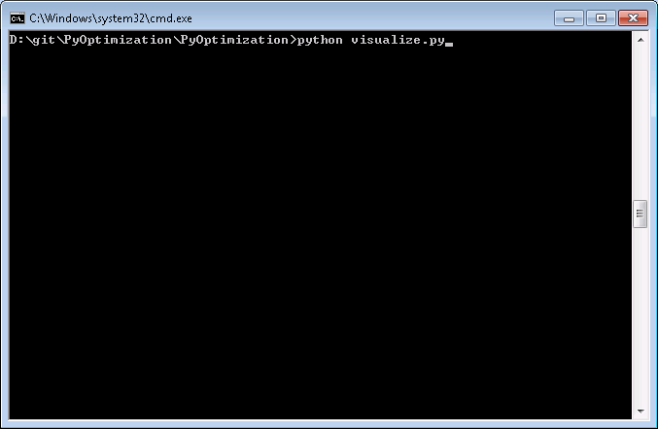

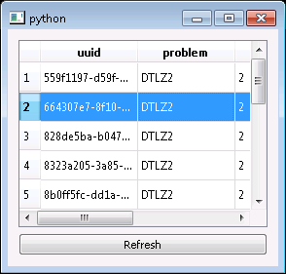

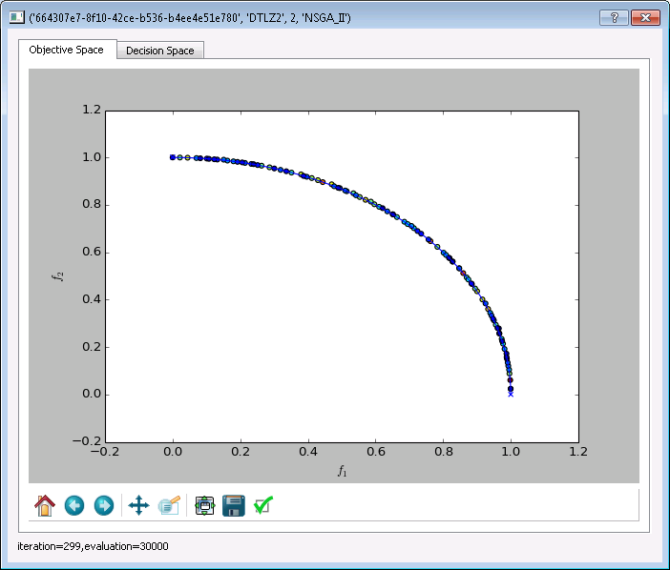

* Evaluating the results:

python visualize.py

